**SOKOINE UNIVERSITY OF AGRICULTURE**

|  |
| --- |
|  |

**CENTER OF INFORMATION COMMUNICATION TECHNOLOGY**

**DIPLOMA IN INFORMATION TECHNOLOGY**

**TITLE: SUA STUDENTS LOANS ALLOCATION MANAGEMENT SYSTEM: CASE STUDY SOKOINE UNIVERSITY OF AGRICULTURE**

**COURCE NAME. COMPUTER PROJECT**

**COURCE CODE. DIT 0223**

|  |  |  |
| --- | --- | --- |
| **NO** | **NAME** | **REGISTRATION NO.** |
| **1.** | **MTUNGUJA, YUSUPH ALLY** | **DIT/E/2018/0212** |

**SUPERVISOR: MR OMARI TUNGA**

**AUGUST, 2020**

# **ACKNOLOGEMENT**

Thankful to God, because I can finish in project report with success. A million thanks to special supervisor Mr. OMARI TUNGA from Sokoine University of Agriculture, Morogoro because I have received for advice and support.

Not forgotten thanks to in family for providing everything, such as money, to buy anything that was related to in project report. They also supported me and encouraged me to complete in project report.

Then I would like to thank all in friends, for guiding me. During preparation of project report, a lot of knowledge and technical skill that I have learned. Without their guidance and information, I do not think I will gain knowledge and manage to do work that have been assigned to.

Finally, a speech to thank the Sokoine University of Agriculture, Morogoro and to all who are involved directly or indirectly.

# 

# **DECLARATION**

A project submitted in partial fulfillment of the requirements for the diploma for information communication technology (ICT) by project report in the Faculty of information technology, University of the Sokoine University of agriculture, 2020 (SUA).

This declaration that show project is in owner of this project, unaided work. It has not been submitted before for any other diploma students in Sokoine University of Agriculture.

**STUDENT NAME: MTUNGUJA, YUSUPH ALLY**

**SIGNATURE: …………….…….……………………**

**SUPERVISOR NAME: Mr. OMARI TUNGA**

**SIGNATURE ………………………………………**

**DATE……………………………...**

# **ABBREVIATIONS**

HELSB Higher education loans board

RAM Random Access memory

MYSQL Structure Query Language

HTML Hypertext Markup Language

HDD Hard disk driver

ERD Entity relation diagram

CSS Cascading style Sheet

SUA Sokoine University of Agriculture

PHP PHP: Hypertext Preprocessor

DFD Data Flow Diagram

XAMPP Cross-Platform (X), Apache (A), Maria DB (M), PHP (P) and Perl (P)

# **TABLE OF CONTENTS**

ACKNOLOGEMENT i

DECLARATION ii

ABBREVIATIONS iii

TABLE OF CONTENTS iv

CHAPTER ONE 1

1.0 INTRODUCTION 1

1.1 Problem Statement 1

1.2 OBJETIVES 2

1.2.1. Main objective 2

1.2.2. In specific objectives is comprises of three objectives; 2

1.3. Significance of project 3

CHAPTER TWO 4

2.0 LITERATURE REVIEW 4

2.1 Overview of student’s loan allocation knowledge base 4

2.1 Description of key concept; 4

CHAPTER THREE 6

3.0 METHODOLOGY 6

3.1 Study area 6

3.2 Material tools 6

3.3 existing knowledge 6

3.4 Gap in existing knowledge 6

3.5. Diagram for throw way prototype 7

3.5.1 Requirement gathering and analysis 7

3.5.2 Quick design or system designing 7

3.5.2.1 Front- user interface design 7

3.5.2.2 Application controller design 7

3.5.2.3 Back-end design 8

3.5.3 Build prototype or development System 8

3.5.4 Customer evaluation 8

3.5.5 Refining prototype 8

3.5.6 Final product/result 8

CHAPTER FOUR 9

4.1. Project execution 9

4.1.1. Scope 9

4.1.2. Project objectives 9

4.1.3. Technical specification 9

4.2. Requirement collection and analysis 10

4.2.1. Data collection 10

4.2.2. Observation 10

4.2.3. Systems Requirements 10

4.3. System designing 11

4.4. Implementation or build prototype 13

4.4.1.1 Code: index.php 14

4.4.2.1. Code Login .php 15

4.4.3. System provide another place for admin dashboard 16

4.4.3.1. Code Admin dashboard.php 17

4.4.4. System provide another place for insert student detail dashboard 18

4.4.4.1 Code addstudent.php 18

4.4.5.1. Code update.php 19

4.4.6. System provide another place for delete student detail dashboard 20

4.4.6.1. Code delete.php 21

4.4.7.1. Code Contact.htm 22

4.5. System Testing 23

4.6 System Evaluation 23

CHAPTER FIVE 24

5.1. Conclusion 24

5.2. Recommendation 26

REFERENCES 27

APPENDICES 28

Appendix 1: Home code 28

Appendix 2: Login code 28

# **CHAPTER ONE**

# **1.0 INTRODUCTION**

Student loan is type of financial assistance designed to help students pay for school related fees, such as tuition, Accommodation, meals and medical fees.

Many of these loans are offered to college students at a low interest rate. Typically, students are not required to repay these loans until the end of a grace period, which begin after they have completed their education.

Our federal loans the government covers the loans interest while the students are not obligated to start paying on the loans until after they graduate.

In Tanzania they have the loan board (HELSB) higher education loans board with the aim to give loans students and recover loan from previously loaned student. Over years now, there increasing number of students seeking higher education but funds to support them have not kept pace with the increasing demands.

Also, many studies conducted on the HESLB have mostly concentrated on its success, sustainability, and effectiveness on loan issuance and repayment.

In many universities they have their students which gets loans from HELSB include Sokoine University of Agriculture. But in Sokoine University of Agriculture their no students’ loans allocation management system which can handle the detail of each student after receive the loans allocation names from loan board. Data are stored in manually (paper form) and published on the notes board which leads in many risks of student’s data like names their loans allocation can be affected because paper is very easy to destruct compare to system. And this paper come from printing all loan allocation names for display for their students to know their allocation name and the place which the students used to view their name is from notes board. (Elsewhere, Bruce Johnstone 2004)

# 

# **1.1 Problem Statement**

Paper searching/manual of names to the notes board lead of wasting time. This is one among the problem for students to take long time to find their names to the notes board. This is happening because the student needs to find their name by looking different paper that are published on the notes board and those different papers, they contain the name of students in different course. So, students when need to find them should follow different step to views their name first should be find the course that students are studying also know where the side that their name is published so all the steps it takes some time to view their names.

Improper handling of data; in Sokoine University of Agriculture student’s and data are not properly because are recorded on the paper form which leads many risk compare when you have system that can handle all data or records of students loans allocation and make the students to feel easy to access their name without any problem. And this problem of handling of data can be big problem for loose of student’s data easy compare to handling data by using system which contains the database which can handling different records without losing the names of their students which get loans from High education students loans board.

Expenses handling stationaries. This problem is happening because all allocation loan name for students are recorded in form of paper so it needs stationaries to printing those papers so all printing activities need to have a money to achieve those activities of printing for students to see their names on notes board but when you have the system no need for printing the paper which contain students names for their loans allocation names.

# 

# **1.2 OBJETIVES**

# **1.2.1. Main objective**

To develop SUA students’ loans allocation management system based on web application/database.

# 

# **1.2.2. In specific objectives is comprises of three objectives;**

i). To analyze data from students which in order develop the SUA students’ loans allocation management system. This objective can be done capturing knowledge from the students that gets loans from loans board through interview by asking different question that can help to get proper information that can help to develop this system.

ii). To design the SUA students’ loans allocation management system. This objective implies two technological and scientific tasks to help to archived in design activities because the design it’s very important things to know the structure of the system by using two place which includes, to design MYSQL database using documented information, To design an interface that can allow searching of loan allocation student from the database.

iii). To implement and test SUA students’ loans allocation management system. This objective is place that can get the final product that can help to solve the problem of storing of information using paper form and after get the final product also can be tested for know if the system is good or not good for user.

# 

# **1.3. Significance of project**

The system will reduce the workload in the stationaries. This is one among the significance of the project when you have system that can handle all student’s loan allocation it’s very easy to reduce the expenses and workload in the stationaries for printing different papers that contains names of students that get loan from higher students loan allocation and also the university can get the benefits for save the money from printing papers on the stationaries.

To save time through this system. Also, this is another the significance in project for reduce the students to go to the notes board for searching their names because it takes a more time. When this system is implementing can help students to save their times for make students to have more time for study hard. Also, can help students to search their names quickly and faster without going on the notes board to check their student’s loans allocation.

To improve quality of SUA student’s loans allocation system. The quality is happening because of transform from paper form to the system. When you have the system can easy to reduce the paper form because the aim of system is to make easy to store and access of data easy.

Reducing risk during loans name published in the notes board. When you have system its very little risk compare when store your data in form of paper. Also, the system can be easy to reduce of plication of those names on the loans allocation names.

## 

# **CHAPTER TWO**

# **2.0 LITERATURE REVIEW**

The HELSB began its operation in July 2005. The act, among other things, empower board to administer loan for Tanzania students for university. Also, the HELSB have the system that combine all university in Tanzania which need to get loan allocation from this board but when those names came to Sokoine University of Agriculture all allocation name of students was stored in form of paper form. So, development this system can help to solve that problem storing information in paper form.

The paper form was the system which are not best for store the data for students. Today most of student information are stored data by using the database which can handle different information of students so the paper forms its used to record small data compare to student’s information.

# 

# **2.1 Overview of student’s loan allocation knowledge base**

Higher education students’ loans board was established 2004, inaugurated by Hon. Minister for Higher Education, Science of technology on 30th march and became operational in July 2005. The objective of the Board is to assist, on a loan basis, needy students who secure admission in accredited higher learning institutions, but who have no economic power to pay for the costs of their education. The board is also entrusted with the task of collecting due to loans from previous loan beneficiaries in order to have a resolving fund in place so as to make the board sustainable. But the higher students’ loans board they are system which handle all students in our country that they get loan from this board. So, because was already system can be easy to get knowledge to develop in system that can handle the student’s names which had get loans so when their names received to our university can easy to store those names for make students easy to access. (Altibach, 2007), (Makulilo, 2012)

# **2.1 Description of key concept;**

**Management information system** is the information system used for decision making, and the coordination, control analysis and visualization of information in organization. Where by improve operational efficiency and allow better decision making also acting as a communication tool.

Also, the study of the management information system involves peoples, processes and technology in an organization context. Goals use of management information system is to increase value and profit for something.

# **CHAPTER THREE**

# **3.0 METHODOLOGY**

This part describes the methodology used to reach the objectives of the project. The framework in which system software is analyses designed and build known as Rapid throw away prototype. decided to choose this methodology because is based on the preliminary requirement. Also, its quickly developed to show how requirement will look visually.

The customers feedback helps drives changes to the requirement, and the prototype is again created until the requirement is baseline.

Also, this technique is usefully for exploring ideas and getting instant feedback for customer requirement.

# 

# **3.1 Study area**

Location of the case study area is at Sokoine University of Agriculture in Morogoro region founded in Tanzania.

# 

# **3.2 Material tools**

The material which will be used to develop the system will be personal computer for implementation and notebook and pen for designing the outlook of the system.

**Software and hardware**

Operating system (window 10), XAMP, Text Editor (Visual Code Studio) AND hardware Computer (dell i3, processor 2.34 GHZ, RAM 4, HDD 500), Plain Paper, Pens**.**

# 

# **3.3 existing knowledge**

Also, in Sokoine University of Agriculture have this system but it conducted manually in form of paper to show allocation loans for student.

# 

# **3.4 Gap in existing knowledge**

The gap that is take place is to replace manual system for show their student loans allocation(paper) to the modern system.

# **3.5. Diagram for throw way prototype**

Requirement gathering

Build prototype

Quick design

**Start**

Final Product/result

Refining prototype

Customer evaluation

**Stop**

Figure 1: Diagram for throw way prototype

# **3.5.1 Requirement gathering and analysis**

This prototyping model starts with requirement analysis. In this phase, the requirements of system are defined in detail. During the process, the users of the system are interviewed to know what is their expectation from the system.

# **3.5.2 Quick design or system designing**

The second phase is a preliminary design or a quick design. In this stage, a simple design of in system is created. However, is not complete design. It gives a brief idea of the system to the user. The quick design helps in developing the prototype. In in project in the designing activities it includes in three parts such as designing the user interface the second will involve the design of middle application architecture and the last is the design of data base.

# **3.5.2.1 Front- user interface design**

In the user interface is to make the users interaction as simple and efficient as possible, in term of accomplishing user goal and can be interacting through web pages that found on that system.

# **3.5.2.2 Application controller design**

Construct a system that has a desirable response to the standard inputs. Also, in order to provide better communication between the user and the system server the scripting language like PHP will be used to transfer data queries from the browser into the database and other way to retrieve the relevant information back to the user on the web page.

# **3.5.2.3 Back-end design**

It includes the database, which will persistently store all data for the application.

# **3.5.3 Build prototype or development System**

The system design needs to be implemented to make it a workable system. This demands the coding of design into computer understandable language, i.e., programming language. This is also called the programming phase in which the programmer converts the program specifications into computer instructions, which we refer to as programs. It is an important stage where the defined procedures are transformed into control specifications by the help of a computer language. The programs coordinate the data movements and control the entire process in a system.

In this project can use HTML, CSS, JavaScript, PHP, and InSQL to archive in goals.

# **3.5.4 Customer evaluation**

In this stage, the proposed system is presented to the client from an initial evaluation. It helps to find out the strength and weakness of the working model. Comment and suggestion are collected from customer and provide to the developer.

# **3.5.5 Refining prototype**

If the user is not happy with the current prototype, you need to refine the prototype according to the user’s feedback and suggestions.

This phase will not over until all the requirement specified by the user are met. Once the user is satisfied with the developed based on the approved final prototype.

# **3.5.6 Final product/result**

Once the final system is developed based on the final prototype, it is thoroughly tested and deployed to production. The system undergoes routine maintenance for minimizing downtime and prevent large scale failures.

# **CHAPTER FOUR**

# **4.1. Project execution**

is important document that serves as a roadmap and reference source for all parties involved in the project itself. The set of goals and potential result, but it also a collection of all necessary steps to be taken in order to achieve its completion.

# **4.1.1. Scope**

PurposeThis document presents the plan for execution of SUA Students loans allocation management system. The specific purpose is to provide the system that can handle the records of student loans that are come from the Loan board. Because all students name that come to our university from Loan board are published on the notes board therefore, it would be more than reasonable to improve the paper base system to the system that match the current technological trends.

# **4.1.2. Project objectives**

To analyze data from students which in order develop the SUA students’ loans allocation management system.

To design the SUA students’ loans allocation management system. This objective implies two technological and scientific tasks to help to archived in design activities because the design it’s very important things to know the structure of the system by using two place which includes,

To implement and test SUA students’ loans allocation management system. This objective is place that can get the final product that can help to solve the problem of storing of information using paper form and after get the final product also can be tested for know if the system is good or not good for user.

# **4.1.3. Technical specification**

Operating system (window 10), XAMP, Text Editor (Visual Code Studio) AND hardware Computer (dell i3, processor 2.34 GHZ, RAM 4, HDD 500), Plain Paper, Pens**.**

# **4.2. Requirement collection and analysis**

The requirements for the study help to provide the general system operations and functionality to be performed by the users.

And these requirements based on user requirements which describes users’ expectations from the proposed system and the other is system requirements for it to work efficiently and more accurate.

# **4.2.1. Data collection**

Data collection techniques to be used in the project so as to obtain data information necessary for

Students Loan Allocation project development include observation and described below;

# **4.2.2. Observation**

I will use observation technique to observe and extract data from different areas as according to

in study. By using observation will consider how students use and obtains their allocation names that are published on the notes board so that, this technique will enhance a collection information about how the current system works even if the method may be time consuming.

# 

# **4.2.3. Systems Requirements**

The requirements for the study help to provide the general system operations and functionality to be performed by the users.

And these requirements based on user requirements which describes users’ expectations from the proposed system and the other is system requirements for it to work efficiently and more accurate.

**4.2.3.1. Functional requirement** it used to describe what something should be able to do. So, in our system must be able to develop system which have ability to provide information about student’s loan allocation management system, and this this system consists name of students, sex, name of bank, and course name.

The system is going to have two users, admin and people to be saved.

The system is going to allow admin to update all information and manage users

**4.2.3.1. Nonfunctional requirement**

Describe the aspects of system that don’t relate to the execution, but rather to its evolution time. Also, non-function requirement is not straight forward the requirement of the system rather it is related to usability. An example of non-functional in in system includes privacy and capacity.

Scalability for better accessibility in every device.

Better component design to get better performance at time.

# **4.3. System designing**

**4.3.1**. Data flow diagram (DFD**)** Show how data enter a system, are transformed in that system, and how it is stored on it. Also is represented by ovals, rectangle, or circle named with single word. In in system the DFD diagram that show the flow of data as shown below,

Database

Enter Student detail Detail

Admin

Final report report

USER(STUDENTS)INTERFACE

Figure 2: Dataflow diagram for project SUA Student loans allocation system

Admin is used to enter the detail of students to the system for help the students to access or see their information from the system.

Student Management systemin the part of management system is using for manage the detail or information of students.

Database also this is another the important part in in system which is used for storing of information or detail of students.

**4.3.2.** Entity relation diagram. It represents the entity model and will show what a system or a database will look like but not explain how to implement it. So, in in system the relation it contains the entity for admin and their attributes including (username and password) and other entity is taking place for students and their attributes includes (Roll no., index no, account no., id, bank name and sex).

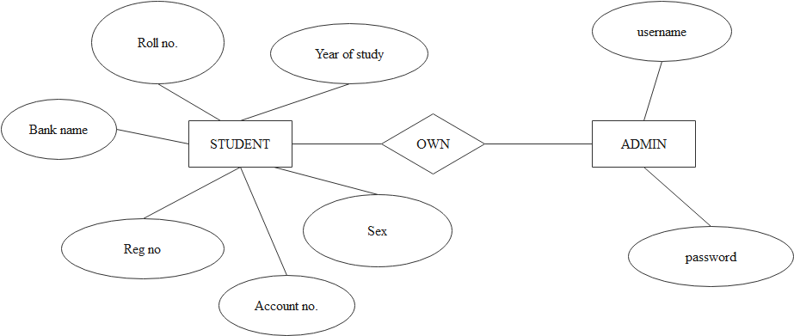

Figure 3:ER diagram show relationship in project

Then below are use case diagram of in proposed SUA students’ loans allocation management system

Login

Update students

Insert students

ADMIN

Delete students

Names

STUDENTS

Account number

Amount and name of account

Figure 1: use case diagram for SUA students’ loans allocation management system

# **4.4. Implementation or build prototype**

On implementation of system that include a hypertext language which is html, scripting language which is JavaScript, styling language which is CSS and side server language which is PHP. By using a virtual studio code software and XAMPP software stack that contain Apache web server, PHP programming and MYSQL Database a system were developed.

4.4.0. Database that show the relationship about in system students’ allocation

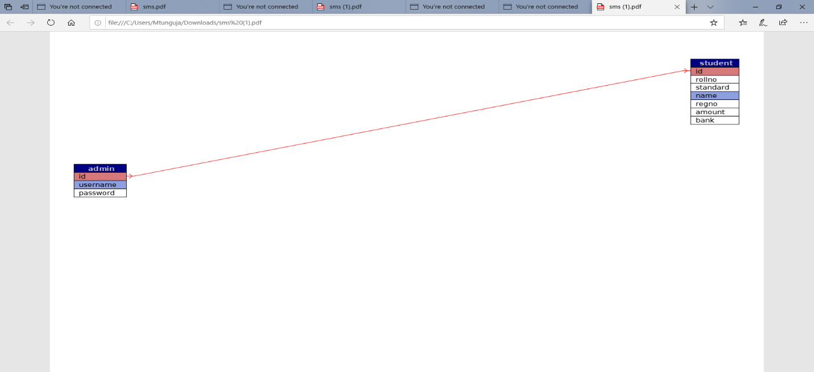

Figure 5: Physical database for Proposed SUA students allocation management system

4.4.1. Index interface

This is place that the students can view their information about the amount, bank and account number and their allocation of their loans.

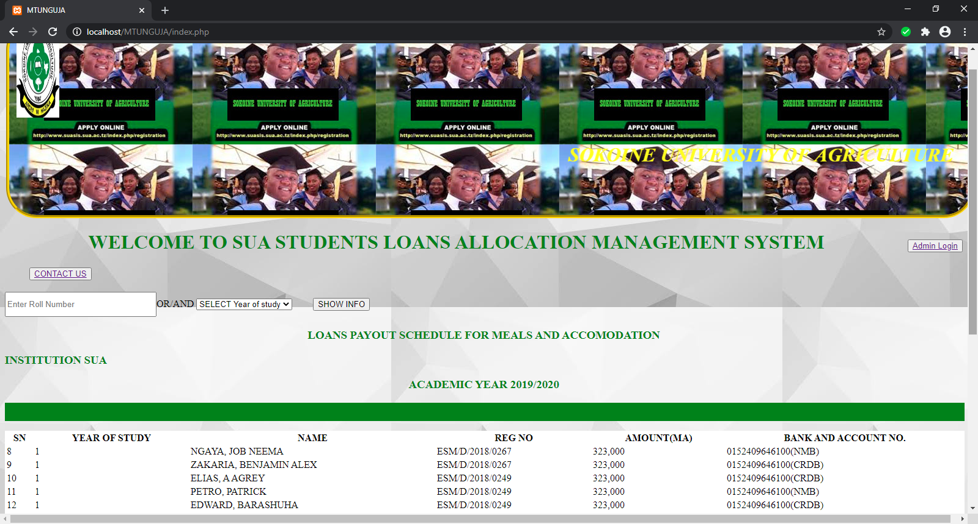

Figure 6: Index interface

# **4.4.1.1 Code: index.php**

<div class="student-info text-center">

<div class="container-fluid">

<div class="row">

<div class="col-md-12 jumbotron">

<form action="index.php" method="post"

<input type="text" name="roll" placeholder="Enter Roll Number" style="width: 240px; height: 35px;"><span>OR/AND<span>

<select name="standard" class="btn btn-info" >

<option>SELECT Year of study</option>

<option>1st</option>

<option>2nd</option>

<option>3rd</option>

<option>4th</option>

<option>5th</option>

</select>

<input type="submit" name="show" value="SHOW INFO" class="btn btn-success text-center" style="margin-left: 30px;" >

</form>

<table style="border=0.1;background-color:white;height:30px;width:1570px">

<tr>

<th class="text-center">SN</th>

<th class="text-center">YEAR OF STUDY</th>

<th class="text-center">NAME</th>

<th class="text-center">REG NO</th>

<th class="text-center">AMOUNT(MA)</th>

<th class="text-center">BANK AND ACCOUNT NO.</th>

**4.4.2. System provide another place for admin login**

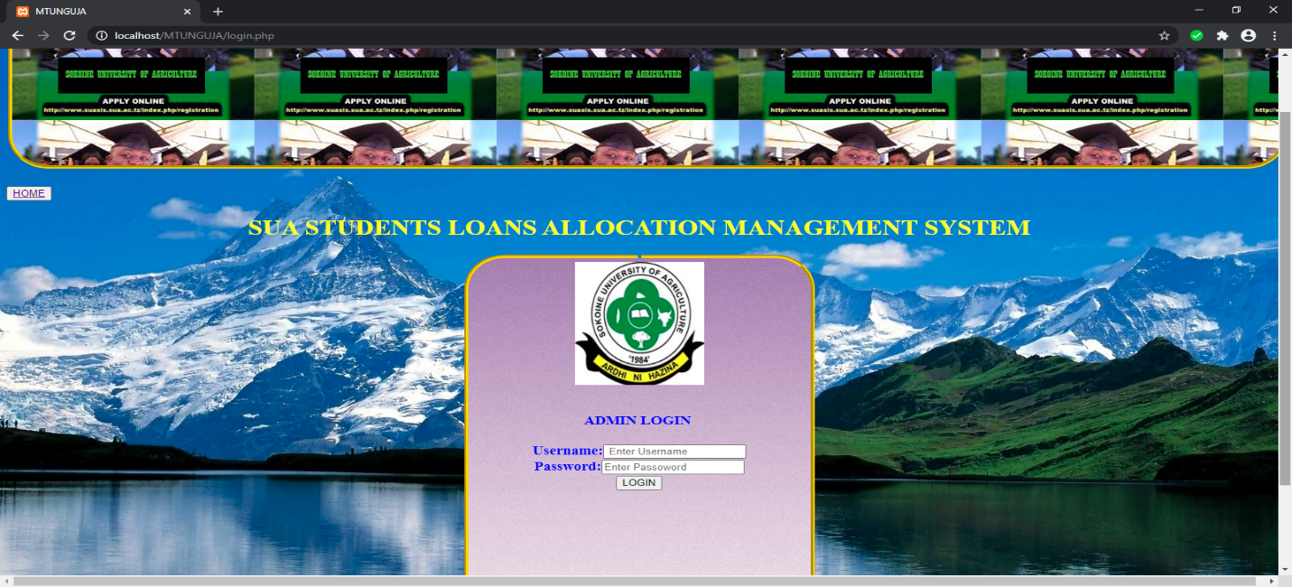

Figure 7: Admin login

# **4.4.2.1. Code Login .php**

<div class="">

<div class="container">

<div class="row">

<div class="col-md-6 col-md-offset-3 jumbotron">

<form action="login.php" method="post">

<h1 style="color:yellow;">SUA STUDENTS LOANS ALLOCATION MANAGEMENT SYSTEM</h1>

<fieldset><legend align="center" ></legend>

<img style="height:180px;width:160px;align:center;" src="dt.4.JPG"/><br><br>

<h3 style="color:blue;">ADMIN LOGIN <br><br>

<div class="form-group">

Username:<input type="text" class="form-control" name="user" placeholder=" Enter Username" required>

</div>

<div class="form-group">

Password:<input type="password" class="form-control" name="password" placeholder="Enter Passoword" required>

</div>

<div class="form-group">

<input type="submit" name="login" value="LOGIN" class="btn btn-success btn-block text-center" >

## 4.4.3. System provide another place for admin dashboard

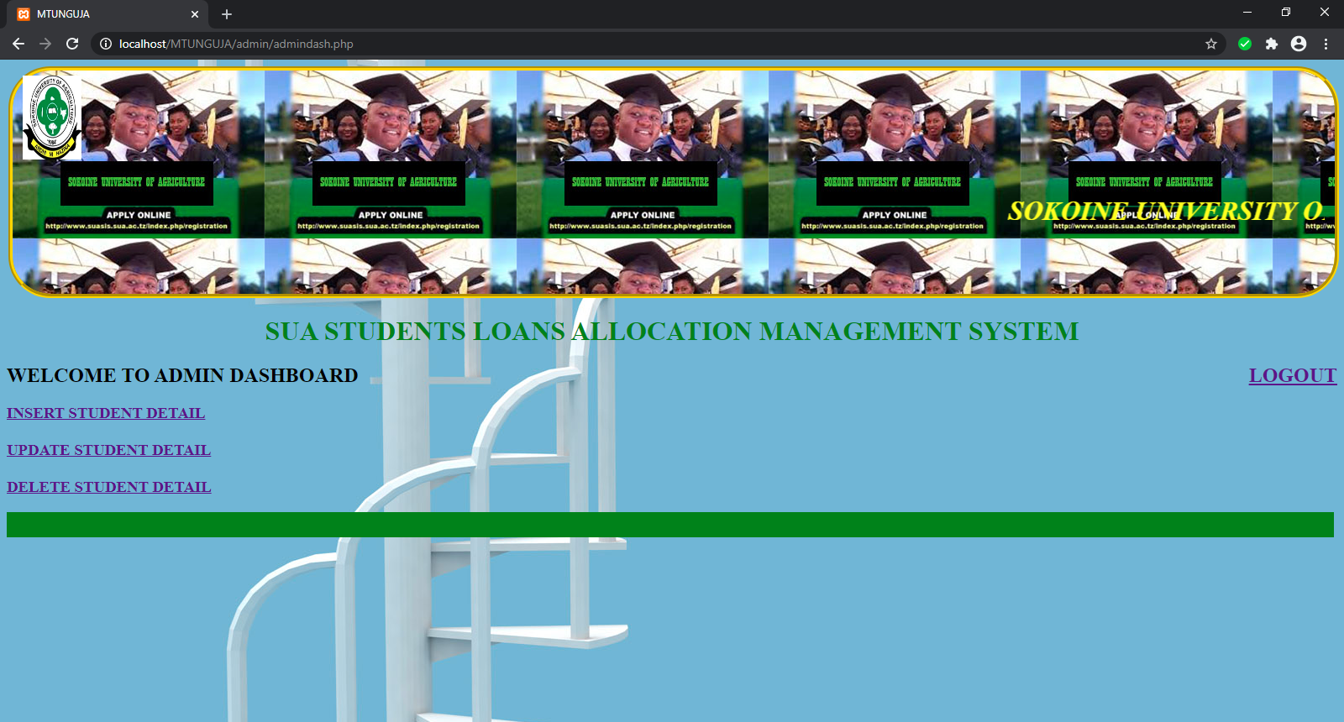

Figure 8: admin dashboard

# **4.4.3.1. Code Admin dashboard.php**

<h1 style="color:YELLOW;"><marquee><i>SOKOINE UNIVERSITY OF AGRICULTURE</i></marquee>

</marquee></fieldset>

<table style="border=0.1;background-color:green;height:30px;width:1580px">

<h1 style="text-align: center;color:GREEN;">SUA STUDENTS LOANS ALLOCATION MANAGEMENT SYSTEM</h1>

<div class="header-section jumbotron">

<div class="container">

<div class="row">

<div class="col-md-12">

<h2 class="text-center">

WELCOME TO ADMIN DASHBOARD

<span><a href="logout.php" class="btn btn-success" style="float: right;">LOGOUT</a><span></button>

</h2>

</div>

</div>

</div>

</div>

<head>

<div class="col-md-6 col-md-offset-3 jumbotron" >

<a href="addstudent.php" class="btn btn-info btn-lg">INSERT STUDENT DETAIL</a><br><br>

<a href="updatestudent.php" class="btn btn-info btn-lg">UPDATE STUDENT DETAIL</a><br><br>

<a href="deletestudent.php" class="btn btn-info btn-lg">DELETE STUDENT

## 4.4.4. System provide another place for insert student detail dashboard

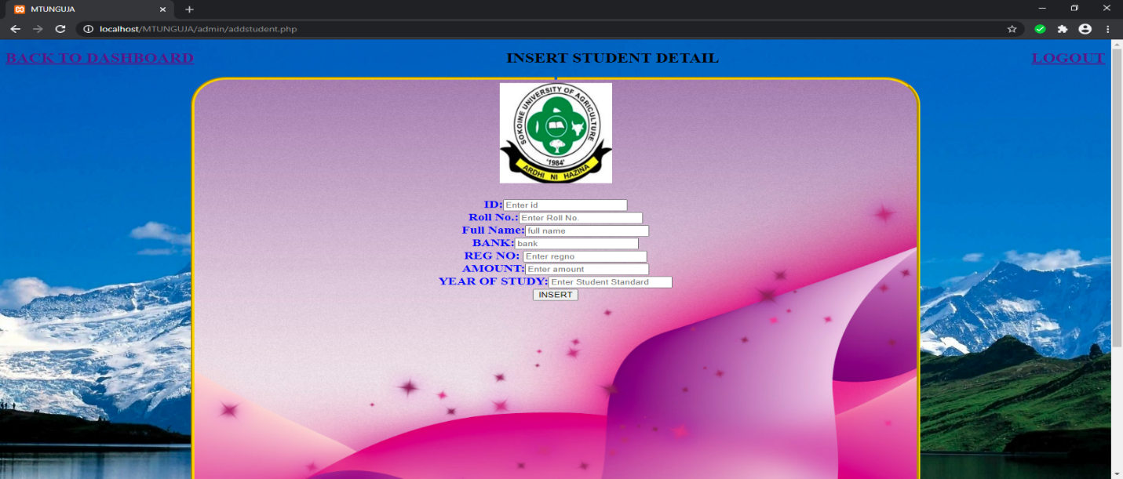

Figure 9: insert or add student detail

# **4.4.4.1 Code addstudent.php**

<div class="form-group">

ID:<input type="text" class="form-control" name="id" placeholder="Enter id" >

</div>

<div class="form-group">

Roll No.:<input type="text" class="form-control" name="roll" placeholder="Enter Roll No." > </div>

<div class="form-group">

Full Name:<input type="text" class="form-control" name="fullname" placeholder="full name" required>

</div>

<div class="form-group">

BANK:<input type="text" class="form-control" name="bank" placeholder="bank" required>

</div>

<div class="form-group">

REG NO: <input type="text" class="form-control" name="regno" placeholder="Enter regno" required>

</div>

<div class="form-group">

AMOUNT:<input type="text" class="form-control" name="amount" placeholder="Enter amount" required>

</div>

<div class="form-group">

YEAR OF STUDY:<input type="number" class="form-control" name="standard" placeholder="Enter Student Standard" required>

</div>

<button type="submit" name="submit" class="btn btn-success btn-lg">INSERT</button>

</form>

</div>

</div>

4.4.5. System provide another place for update student detail dashboard

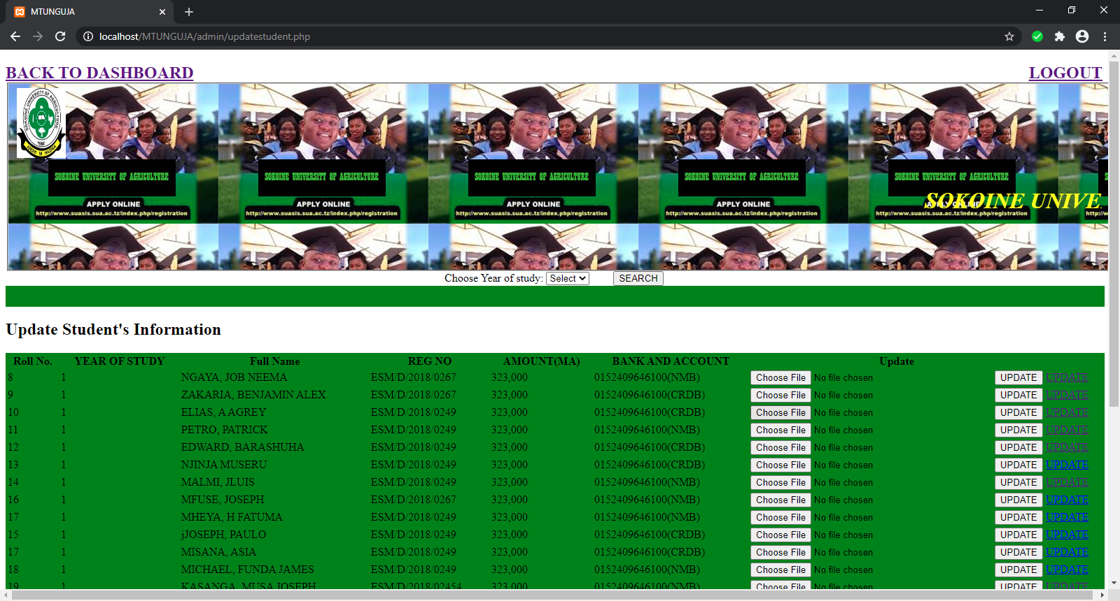

Figure 10: update of students

# **4.4.5.1. Code update.php**

<div class="container jumbotron">

<div class="row">

<div class="col-md-6 col-md-offset-3">

<h2 class="text-center">UPDATE STUDENT DETAIL</h2>

<fieldset><legend align="center" ></legend>

method="post" enctype="multipart/form-data">

<div class="form-group">

Roll No.:<input type="text" class="form-control" name="roll"

" required>

</div>

<div class="form-group">

REG NO: <input type="text" class="form-control" name="regno" value="<?php echo $regno;?>" required>

</div>

<div class="form-group">

AMOUNT:<input type="text" class="form-control" name="amount" value="<?php echo $amount;?>" required>

</div>

<div class="form-group">

YEAR OF STUDY:<input type="number" class="form-control" name="standard" value="<?php echo $Standard;?>" required>

</div>

<button type="submit" name="submit" class="btn btn-success btn-lg">UPDATE</button>

</form

## 4.4.6. System provide another place for delete student detail dashboard

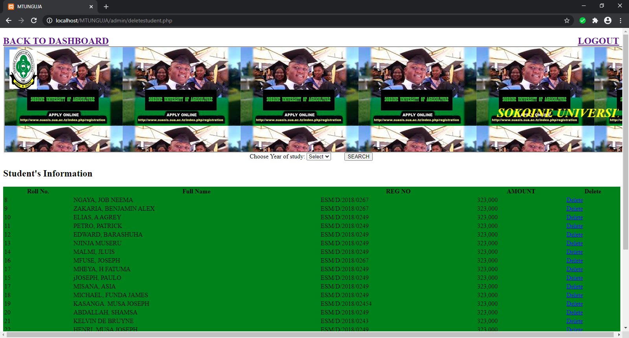

Figure 11: delete students’ detail.

# **4.4.6.1. Code delete.php**

class="container">

<div class="row">

<div class="col-md-6 col-md-offset-3 jumbotron ">

<div style="text-align: center;">

<form action="<?php echo htmlspecialchars($_SERVER["PHP_SELF"]);?>" method="post" enctype="multipart/form-data" >

Choose Year of study: <select name="standard" class="btn btn-info" style="margin-right: 30px;"><option>Select</option>

<option>1st</option>

<option>2nd</option>

<option>3rd</option>

<option>4th</option>

<option>5th</option>

</select>

<input type="submit" name="search" value="SEARCH"

table-bordered table-responsive text-center">

<h2 class="text-center">Student's Information</h2>

<table style="border=0.1;background-color:green;height:30px;width:1570px">

<tr>

<th class="text-center">Roll No.</th>

<th class="text-center">Full Name</th>

**4.4.7. System provide another place for contact us for student to get easier communication**

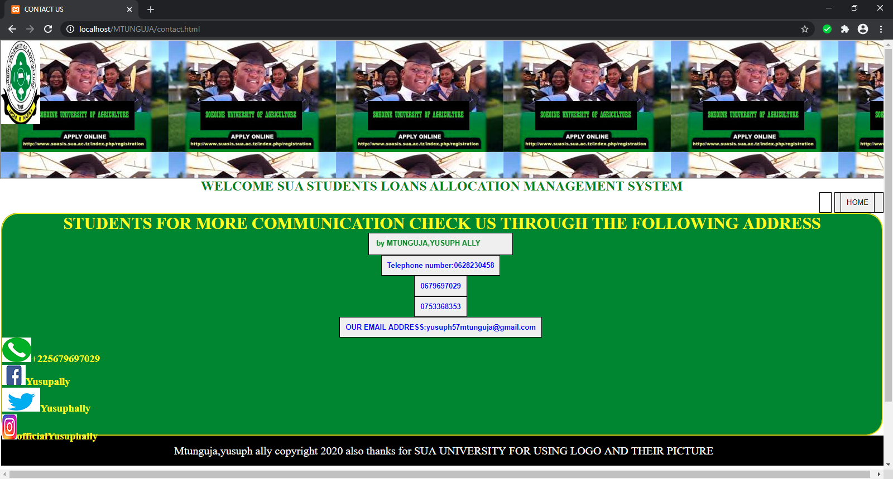

Figure 11: Contact or communication for student

# **4.4.7.1. Code Contact.htm**

<fieldset style="width:1580px;height:400px;border-radius:30px;border-color:yellow;background-color:rgb(33, 131, 38);">

<h2 style ="color:yellow;font-size:30px;"><center>STUDENTS FOR MORE COMMUNICATION CHECK US THROUGH THE FOLLOWING ADDRESS</center></h2>

<center> <a href=id="btn-group"><button type="button" class="btn btn-info"><h4 style="color:green;"><marquee>created by MTUNGUJA,YUSUPH ALLY</marquee> </button></a></center>

<center> <a href=id="btn-group"><button type="button" class="btn btn-info"><h4 style="color:blue;">Telephone number:0628230458</button></a></center>

<center> <a href=id="btn-group"><button type="button" class="btn btn-info"><h4 style="color:blue;">0679697029</button></a></center>

<center> <a href=id="btn-group"><button type="button" class="btn btn-info"><h4 style="color:blue;">0753368353</button></a></center>

<center> <a href=id="btn-group"><button type="button" class="btn btn-info"><h4 style="color:blue;">OUR EMAIL ADDRESS:yusuph57mtunguja@gmail.com </button></a></center>

<h3 style="text-align:left; color:yellow;"><p><div class="promo-title"><strong><img src="logo2.png" class="service-img">+225679697029</strong></P></h3

<h3 style="text-align:left; color:yellow;"><p><div class="promo-title"><strong><img src="gf.png" class="service-img">officialYusuphally</strong></P></h3>

#### 

# **4.5. System Testing**

On this project the testing that have done is called unit test because A unit is the smallest testable piece of software, which may consist of hundreds or even just a few lines of source code, and generally represents the result of the work of one programmer. To expert explore all functionality of system which include insert students, update students, delete students, sign in, and log out and security. On end user side which concern a student also was not bad even the review where different because end user always doesn’t know much about how system should be developed actually when a basic functionality added to system, they think it enough so the review was good to them. Example of testing that have done in in system includes in log in place for admin, update, insert and delete place which all this module can form in system.

# **4.6 System Evaluation**

In this stage, the proposed system is presented to the client from an initial evaluation. It helps to find out the strength and weakness of the working model. Comment and suggestion are collected from customer and provide to the developer. And this evaluation can be done through the students which is main purpose for helps the student from our Sokoine University of Agriculture (SUA) to get their loans allocation names from this system without using manual system which is using paper to publishing on notes board.

# 

# **CHAPTER FIVE**

# **5.1. Conclusion**

Student loan is type of financial assistance designed to help students pay for school related fees, such as tuition, Accommodation, meals and medical fees. Many of these loans are offered to college students at a low interest rate. Typically, students are not required to repay these loans until the end of a grace period, which begin after they have completed their education. In many universities they have their students which gets loans from higher education loans board (HELSB) include Sokoine University of Agriculture. But in our university Sokoine University of Agriculture their no students’ loans allocation management system which can handle the detail of each student after receive the loans allocation names from loan board. Data are stored in manually (paper form) and published on the notes board which leads in many risks of student’s data like names their loans allocation can be affected because paper is very easy to destruct compare to system. And this paper come from printing all loan allocation names for display for their students to know their allocation name and the place which the students used to view their name is from notes board. (Elsewhere, Bruce Johnstone 2004). The problem that have seen and need to solve that problem as follows Paper searching/manual of names to the notes board lead of wasting time, Improper handling of data, Expenses handling stationaries. And in objectives of in projects to develop SUA students’ loans allocation management system based on web application/database (Main objective). And specific objectives as follows to analyze data from students which in order develop the SUA students’ loans allocation management system, to design the SUA students’ loans allocation management system, to implement and test SUA students’ loans allocation management system. The significance on this project as follows the system will reduce the workload in the stationaries, to save time through this system, to improve quality of SUA student’s loans allocation system, reducing risk during loans name published in the notes board. Also, in literature review in this project as follows The HELSB began its operation in July 2005. The act, among other things, empower board to administer loan for Tanzania students for university. Also, the HELSB have the system that combine all university in Tanzania which need to get loan allocation from this board but when those names came to our university Sokoine University of Agriculture (SUA) all allocation name of students was stored in form of paper form. So, development in system can help to solve that problem storing information in paper form.

The paper form was the system which are not best for store the data for students. Today most of student information are stored data by using the database which can handle different information of students so the paper forms its used to record small data compare to student’s information. And the methodology that is take place in this project This part describes the methodology used to reach the objectives of the project. The framework in which system software is analyses designed and build known as Rapid throw away prototype. decided to choose this methodology because is based on the preliminary requirement. Also, its quickly developed to show how requirement will look visually. And material that have been using in this project includes Operating system (window 10), XAMP, Text Editor (Visual Code Studio) AND hardware Computer (dell i3, processor 2.34 GHZ, RAM 4, HDD 500), Plain Paper, Pens**. And** the place that this project is conducted Location of the case study area is at So koine University of Agriculture (SUA) in MOROGORO REGION founded in TANZANIA. Also, in designing. In this stage, a simple design of in system is created. However, is not complete design. It gives a brief idea of the system to the user. The quick design helps in developing the prototype. In in project in the designing activities it includes in three parts such as designing the user interface the second will involve the design of middle application architecture and the last is the design of data base. Also, in implementation on implementation of system that include a hypertext language which is html, scripting language which is JavaScript, styling language which is CSS and side server language which is PHP. By using a virtual studio code software and XAMPP software stack that contain Apache web server, PHP programming and MYQL Database a system were developed. After all steps that have taken in in project also should be test On this project the testing that have done is called unit test because A unit is the smallest testable piece of software, which may consist of hundreds or even just a few lines of source code, and generally represents the result of the work of one programmer. And final evaluation in this stage, the proposed system is presented to the client from an initial evaluation. It helps to find out the strength and weakness of the working model. Comment and suggestion are collected from customer and provide to the developer.

# **5.2. Recommendation**

A representative of SUA students’ loans allocation management system should convene funding, logistics, and other aspect of a coordinated, multiyear communication to improve the students understand of this system that shows their names and allocations of loans.

# **REFERENCES**

Altibach, P. G., & Knight, J. (2007). The internationalization of higher education: Motivations and realities. Journal of Studies in International Education, 11, 290. http://dx.doi.org/10.1177/1028315307303542

Makulilo, V. (2012). Disconcerted Success of Students’ Loans in Financing Higher Education in Tanzania. African Review, 41(2), 108-135.

Johnstone, B. D. (2004). Higher Education accessibility and financial viability: The role of student’s loans. Paper in the Guni series on the social commitment of Universities in Higher Education in the World 2006, the Financing of Universities

Dunia, M., 2014. Factors affecting good performance of issuing the students’ loan: a case of higher education Students’ loans board (HESLB) (Doctoral dissertation, Mzumbe University).

Goddard, A. and Ooi, K., 1998. Activity-based costing and central overhead cost allocation in universities: a case study. Public Money and Management, 18(3), pp.31-38.

Larraín, C. and Zurita, S., 2008. The new student loan system in Chile’s higher education. Higher Education, 55(6), pp.683-702.

Atuahene, F., 2008. The challenge of financing higher education and the role of student loans scheme: an analysis of the student loan trust fund (SLTF) in Ghana. Higher Education, 56(4), pp.407-421.

Nyahende, V.R., 2017. Students’ Loans by Financial Institutions: The Way to Reduce a Burden for Government Funding to Higher Education in Tanzania. IJLTER. ORG, 16(11), pp.92-115.

# **APPENDICES**

# **Appendix 1: Home code**

<input type="text" name="roll" placeholder="Enter Roll Number" style="width: 240px; height: 35px;"><span>OR/AND<span>

<select name="standard" class="btn btn-info" >

<option>SELECT Year of study</option>

<option>1st</option>

<option>2nd</option>

<option>3rd</option>

<option>4th</option>

<option>5th</option>

</select>

<input type="submit" name="show" value="SHOW INFO" class="btn btn-success text-center" style="margin-left: 30px;" >

</form>

<h3 style="text-align: center;color:green;">LOANS PAYOUT SCHEDULE FOR MEALS AND ACCOMODATION

<h3 style="text-align: LEFT;color:GREEN;">INSTITUTION SUA <h3 style="text-align: center;color:green;">ACADEMIC YEAR 2019/2020

<table class="table table-striped table-bordered table-responsive text-center">

# **Appendix 2: Login code**

background:url(2.jpg);

}

fieldset {

border-width:5px;

height:580px;

width:400px;

border-radius:50px;

border-color: gold;

</style>

</head>

<div class="admin-dashboard text-center">

<div class="container">

<h3 style="color:yellow;">

<div>

<div class="row">

<div class="col-md-6 col-md-offset-3 jumbotron" >

<a href="addstudent.php" class="btn btn-info btn-lg">INSERT STUDENT DETAIL</a><br><br>

<a href="updatestudent.php" class="btn btn-info btn-lg">UPDATE STUDENT DETAIL</a><br><br>

<a href="deletestudent.php" class="btn btn-info btn-lg">DELETE STUDENT DETAIL</a>

</div>

</div>

</div>

</div>

</div>

</style>

<?php include('../footer.php')?>